FIFTEEN SHARDS OF LIGHT

Level_03_Visual_Master_Concept_Package_v1.1
Visual Master Concept • Environment Concept • Blender Art Direction
Репозиторий: MindDevastation/fifteen-shards-of-light
Источник истины: Level_03_Narrative_and_Level_Scenario_Package.docx
Статус: VISUAL MASTER CONCEPT CANDIDATE — Producer approval required
Режим: documentation only — без Godot runtime-изменений, Blender production, GLB, branches и PR

Контроль | Значение
Глава | Level_03 — «После наших разговоров»
Canonical shards | Shard_05 / Shard_06 / Shard_07
Visual flow | Wind Trace → Playful Spark → Breathing Meadow → Synthesis → Main Text → Calm Portal Activation
Главное эмоциональное правило | Героиня не сломана, ее не чинят. Мир жив с самого начала. Изменяется ясность и легкость восприятия автора, а не ценность или “целостность” героини.
Authority split | Narrative package = textual authority. This document’s text and diagrams = visual intent authority. AI images = mood/composition references only.

Version 1.1 change log
ID | Изменение v1.1
V11-01 | Заменены противоречивые AI mood references: убраны shrine/altar, circular hub и доминирующий активный portal.
V11-02 | Final Overlook Landmark и Portal Core разделены как разные визуальные функции; Portal Core активируется только после закрытия main text.
V11-03 | Initial-state color rule уточнен: натуральные цвета видимы, richness ≈ 65–80% final state; grayscale/dead reading запрещен.
V11-04 | Semi-hero budget сокращен до трех families: Wind_Arch_Family, SeedPod_Perch_Family, Wind_Petal_Family.
V11-05 | Playful Spark зафиксирован как primary locked beat: abstract warm light impulse, без лица, глаз, крыльев и mascot behavior.
V11-06 | Breathing Meadow: три объекта сразу видимы, persistent, any order. Открыт только activation verb: E interaction или safe proximity.
V11-07 | Заменены формулировки “camera-friendly low arena” и “tallest, brightest...” на утвержденные Producer формулировки.
V11-08 | Пересобраны Figures 5, 7 and 8 без clipping, label overlap и cramped text.
V11-09 | Producer approval table очищена: ранее locked decisions больше не отображаются как unresolved.

0. Source hierarchy, scope and authority
- Primary authority: Level_03_Narrative_and_Level_Scenario_Package.docx.
- Continuity references: approved Level_02 visual/gameplay/art documents — только для continuity тона, масштаба и material language, без копирования arena structure.
- Legacy Level_03 placeholder не является каноном и не определяет новую композицию.
- Text and diagrams in this package are authoritative for visual intent. AI images are explicitly non-authoritative mood/composition references.
- Этот этап не задает Godot architecture, NodePaths, state machines, exact runtime coordinates, Blender source hierarchy или GLB production plan.

1. Visual thesis and emotional reading

1.1 Visual thesis
Level_03 читается как воздушная прогулка-послесвечение: одна непрерывная S-образная роща над мягким туманом, где память о разговорах становится видимой через следы ветра, абстрактный теплый световой импульс и постепенно раскрывающееся открытое пространство. Мир уже жив с первого кадра; после shard events он не “оживает”, а становится яснее, теплее и легче воспринимается.

1.2 Emotional route
- Anticipation — тихая заводь, естественные цвета уже присутствуют, дальний overlook помогает ориентироваться.
- Lingering intonation — wind arches и ribbons делают “послевкусие интонации” видимым без literal voice magic.
- Sudden shared laughter — Playful Spark появляется как abstract warm light impulse и мягко взаимодействует с обычными seed-pods.
- Becoming lighter — Breathing Meadow раскрывает горизонт и воздух; изменение относится к состоянию автора, не к “исправлению” героини.
- Quiet understanding — после Shard_07 мотивы сходятся у Final Overlook Landmark, но Portal Core остается inactive до закрытия main text.

1.3 Canonical textual anchor
ID | Locked text / function
Shard_05 | После наших разговоров я ещё долго вспоминаю твою интонацию.
Shard_06 | Мне особенно нравится, как ты вдруг смеёшься над какой-нибудь полной ерундой.
Shard_07 | Рядом с тобой я и сам чаще смеюсь и ненадолго перестаю быть таким серьёзным.
Main text | Сначала я просто заметил, что жду наших разговоров. Потом понял, что после них ещё долго вспоминаю твою интонацию, а когда ты внезапно смеёшься над какой-нибудь ерундой, я и сам перестаю быть таким серьёзным. Мне дорого не только то, как легко мне бывает рядом с тобой. Мне дорога ты.

2. Shape language, landmark hierarchy and environmental storytelling

2.1 Shape language
- Rounded, open, safe silhouettes: broad arches, petal forms, low ruins, soft cliff shelves, oval glades.
- Asymmetry at composition scale: vegetation, ruin fragments and path framing should avoid formal arena symmetry.
- Open sky and horizon are active design elements. Fewer enclosing walls; more view-throughs and distance layers.
- Natural motion is always present: ribbon drift, grass groups, hanging vines, leaf movement and slow motes.
- No punitive silhouette language: no fortress teeth, sharp cages, challenge pylons, altar steps or combat staging.

2.2 Landmark hierarchy
Priority | Landmark | Locked role
Primary | Final Overlook Landmark | Clearest distant silhouette and route-orientation landmark. Visible from the beginning; calm and environmental; not an active portal.
Secondary | Wind_Arch_Family | Repeating route landmark and visual memory rhythm. Guides attention without gates or spawned platforms.
Secondary | Wind_Petal_Family | Three large open silhouettes in Breathing Meadow; immediately visible and readable as any-order targets.
Tertiary | SeedPod_Perch_Family | Low local focal points for Playful Spark inside the camera-friendly oval glade.
Support | Path / ruin / cliff-edge compositions | Frame sightlines, protect route readability and build a unique overlook composition without new hero families.

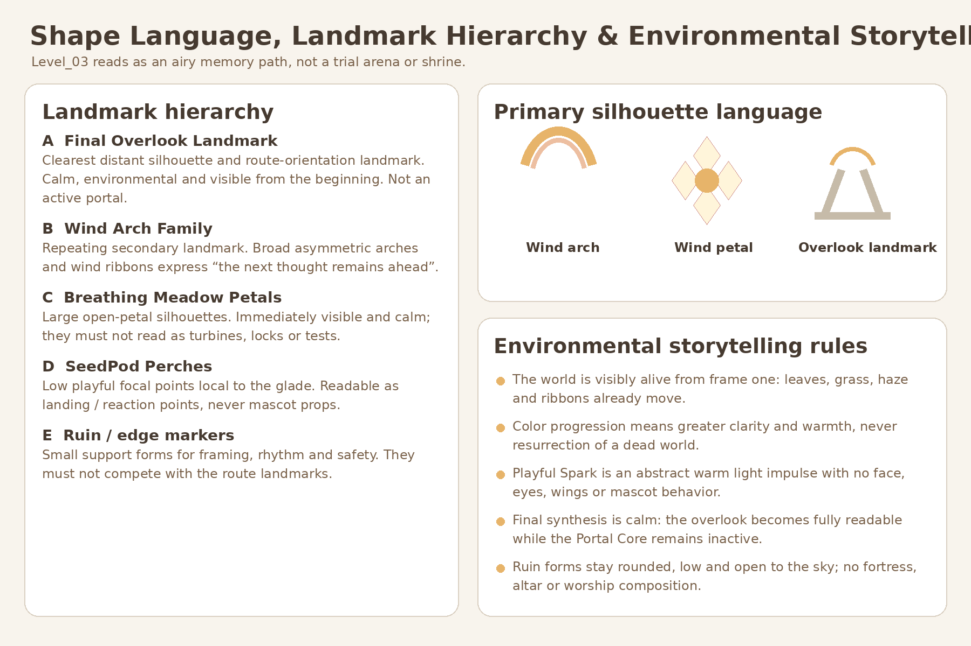
Figure 1. Shape language and landmark hierarchy. Diagram = authoritative visual intent; not final geometry.

3. Top-down composition with approximate relative proportions
Macro model: одна непрерывная S-образная sky-grove walk с тремя расширениями. Это не central hub, не circular arena и не set of trials. Recommended concept-planning envelope: approximately 96–110 m long by 38–48 m wide. Exact coordinates belong to later Gameplay Design / Technical Architecture.
Zone | Approximate relative size | Visual function
Quiet Inlet | 10–12 m entry shelf | Safe spawn, first arch, natural color visible, distant overlook landmark readable.
Wind Trace path | 5–6 m broad route; 3 wind arches | Continuous path; ripples guide attention without physical route spawning.
Shard_05 Overlook | 8–10 m small expansion | Pause with safe edge and preview of the Playful Glade.
Playful Glade | 18–22 m camera-friendly oval glade | Three visible perches; abstract spark impulse stays in composition.
Connector / Exhale | 5–6 m short route | No new rule; lowers visual noise before the meadow.
Breathing Meadow | 24–28 m widest open zone | Three visible persistent any-order wind-petals and a calm center memory point.
Final Overlook Landmark | 12–16 m calm vista composition | Visible from start as orientation landmark. Portal Core remains dormant until after main text.

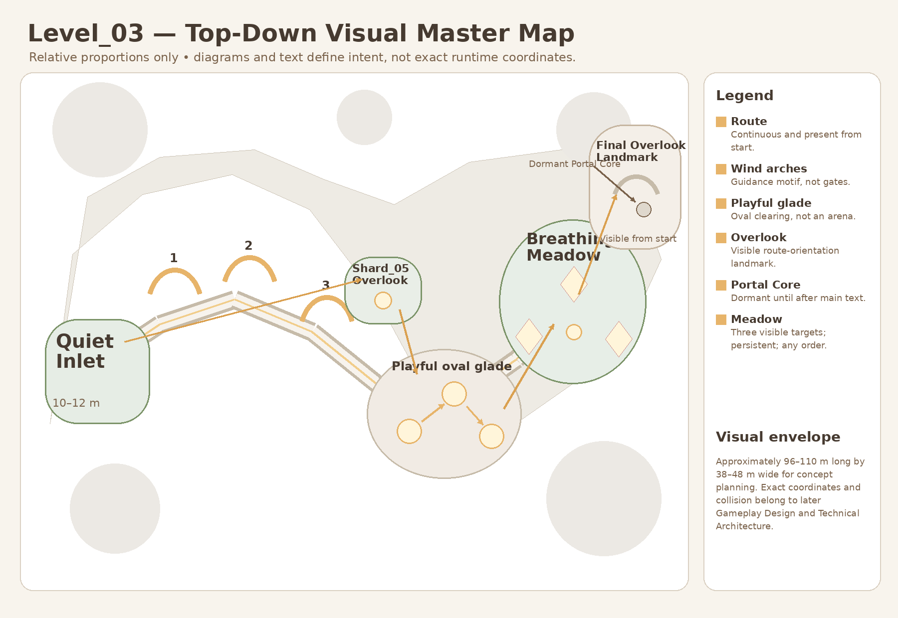
Figure 2. Top-down visual master map. Relative proportions only; no exact runtime coordinate authority.

4. Player sightlines and visual route
Rule: каждый следующий beat читается через один dominant silhouette, один secondary depth cue и один motion cue. UI arrows, minimap, floating quest markers и mandatory text instructions не нужны.
Beat | Visual reading
Quiet Inlet | Final Overlook Landmark visible as a calm silhouette. Portal Core inactive and not visually dominant.
Wind Trace | Three broad arches establish route rhythm; a ripple points from current to next.
Shard_05 Overlook | A safe pause with the warmer oval glade already readable ahead.
Playful Glade | Three low perches remain inside one composition; spark impulse has no mascot body language.
Connector / Exhale | Cleaner sky and reduced prop density prepare the meadow reveal.
Breathing Meadow | All three petals visible from the entrance; central point communicates persistent progress.
Synthesis / Exit | Overlook fully readable; Portal Core remains dormant during main text, then activates calmly.

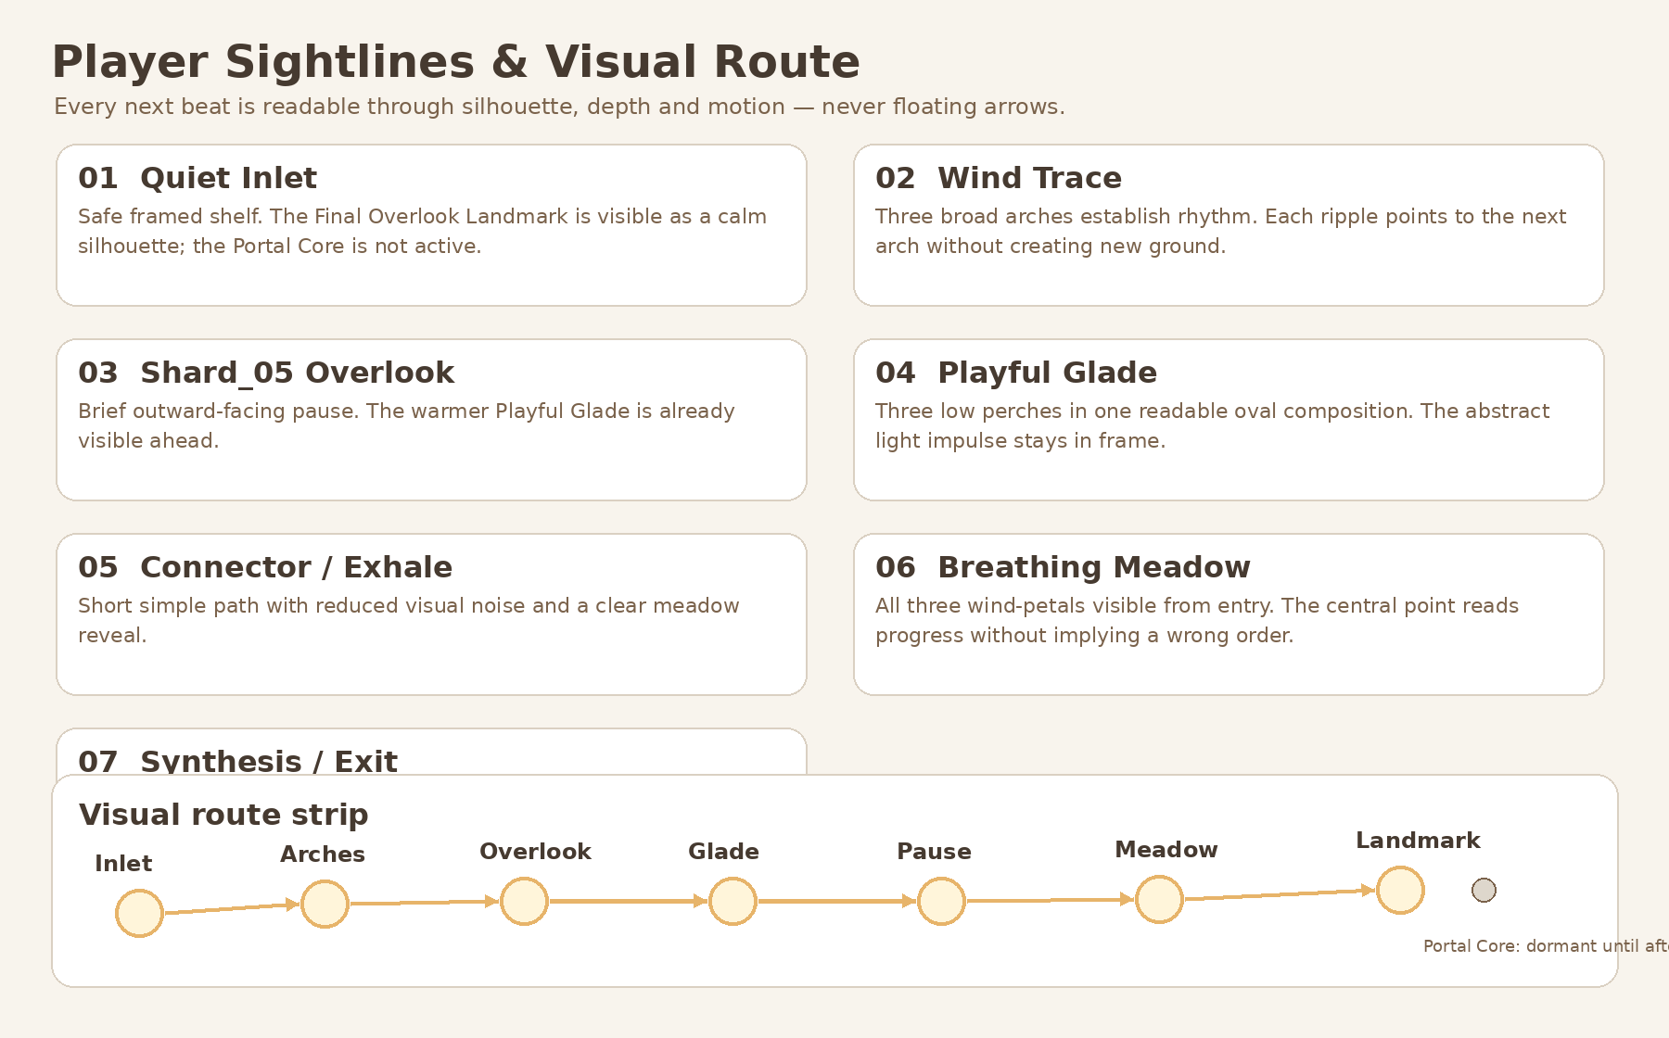
Figure 3. Player sightlines and visual route strip. Diagram = authoritative visual intent.

5. AI mood / composition references — non-authoritative
Все изображения этого раздела являются mood/composition references only. Они не определяют точную геометрию, hero asset count, runtime route, portal state или production hierarchy. В случае конфликта текст и diagrams этого документа имеют приоритет.
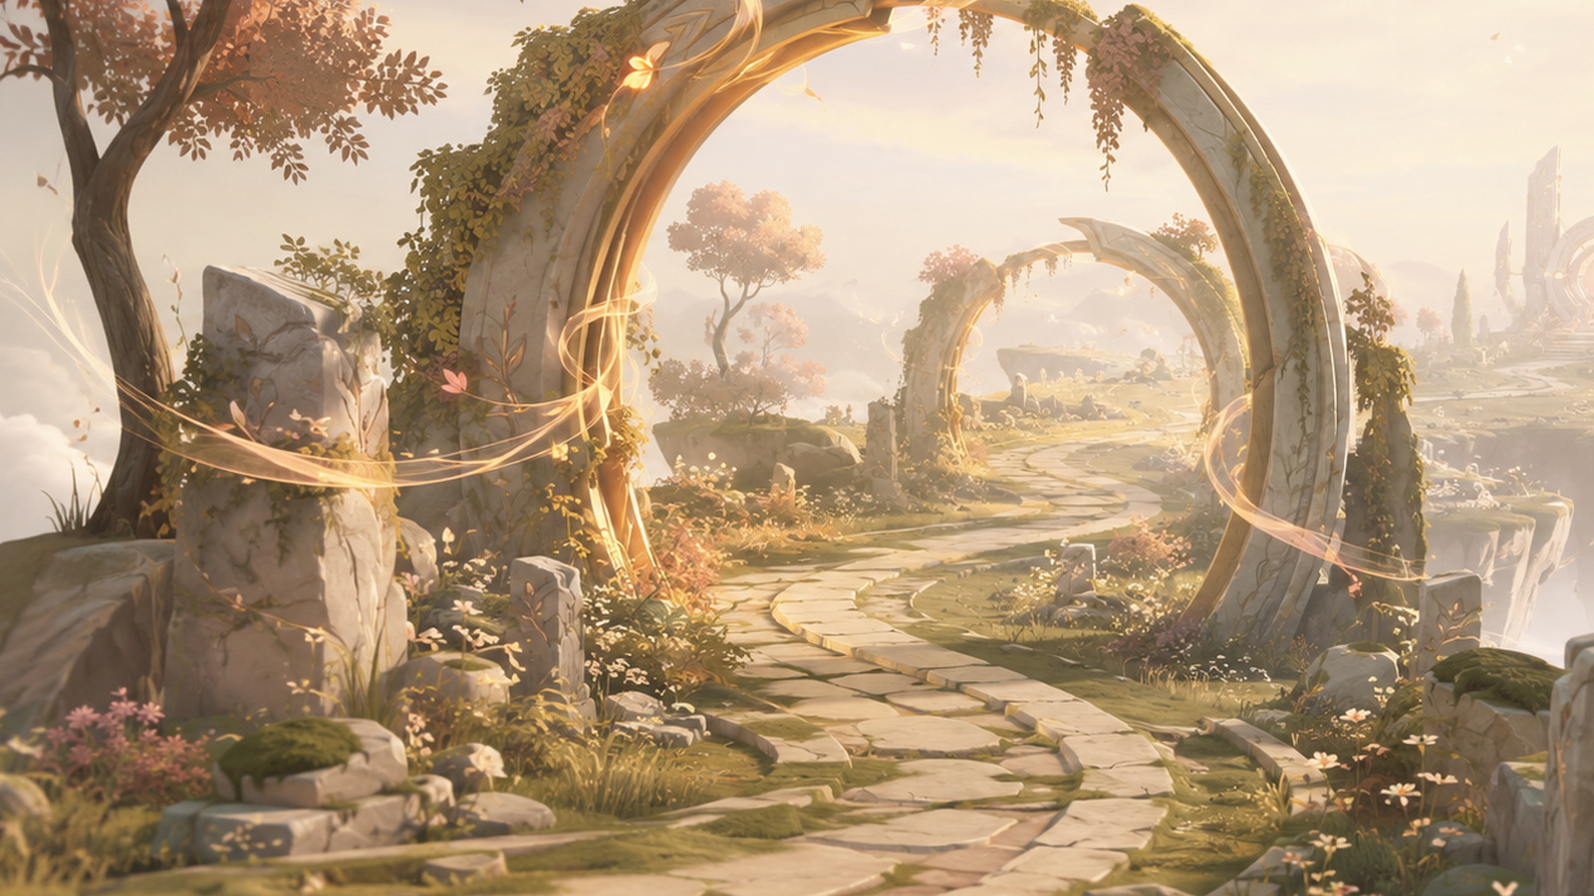
Figure 4A. Continuous asymmetrical route mood: broad traversal, open sky, no hub, no altar, no dominant active portal.
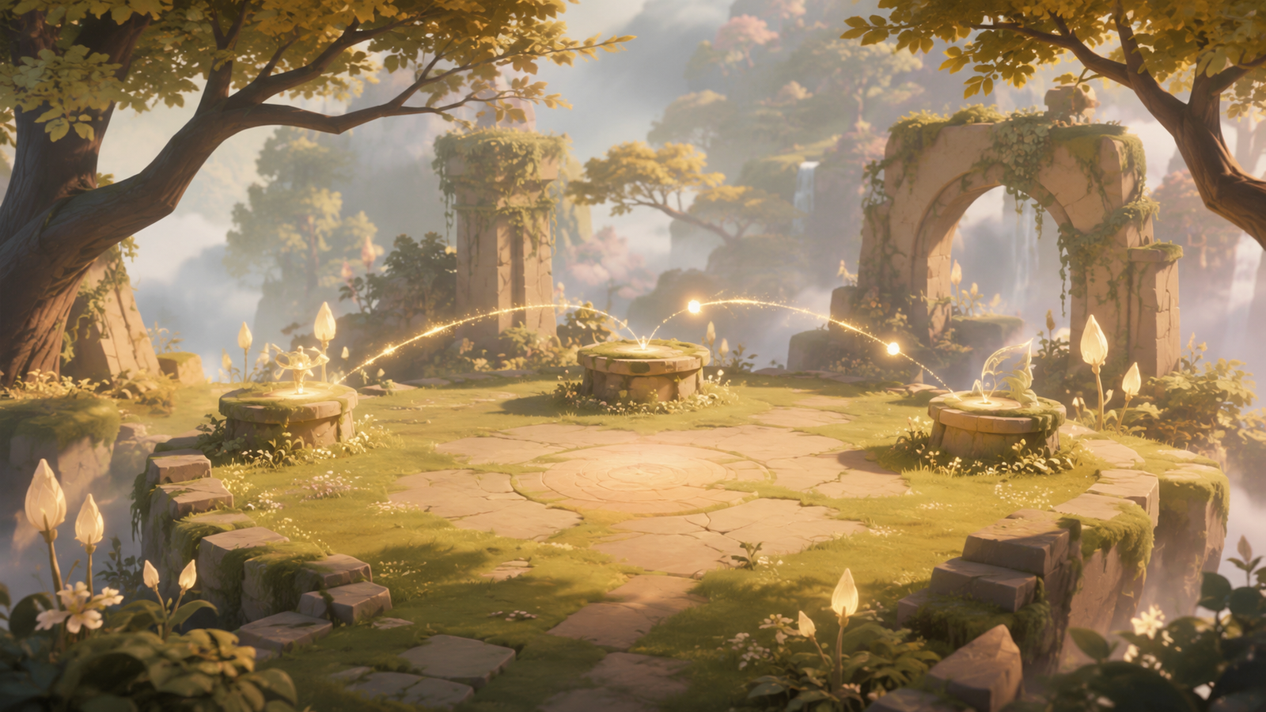
Figure 4B. Restrained Playful Glade mood: oval space, three visible perches, warm abstract motion; not a challenge arena.

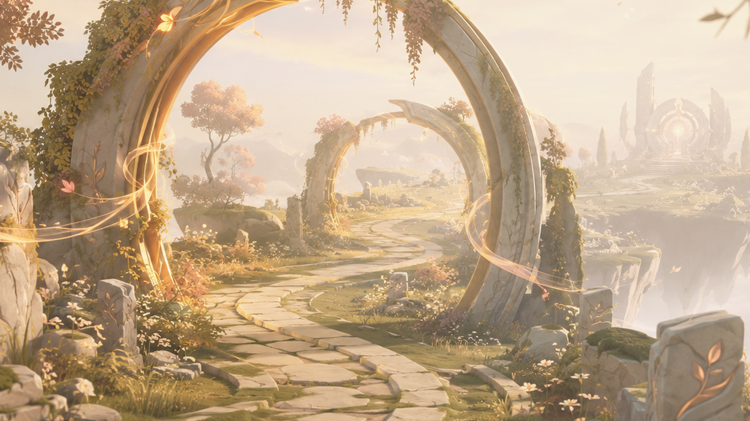
Figure 4C. Final Overlook Landmark mood: environmental route-orientation silhouette; Portal Core is not active in this reference.
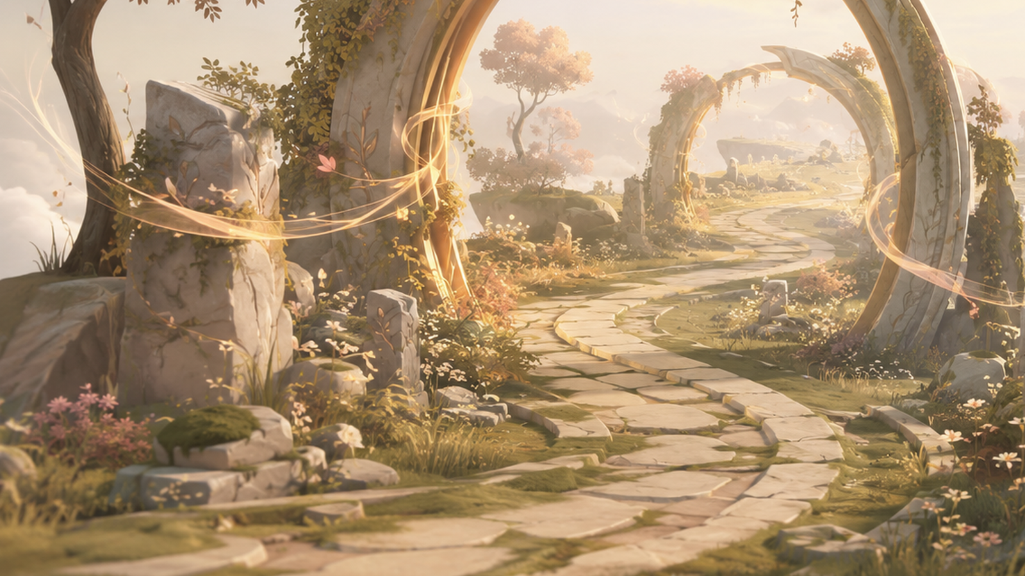
Figure 4D. Safe traversal and material mood: warm stone, moss, soft ruins, open horizon, no shrine framing.

6. Puzzle visual concepts

6.1 Wind Trace — locked visual form
- Three broad wind arches stand on one continuous route.
- The nearest arch auto-pulses once and sends a soft ribbon ripple to the next arch.
- No route spawning, no fail state, no timer, no audio dependency.

6.2 Playful Spark — primary locked beat
- One abstract warm light impulse moves between three visible low perches when the player approaches.
- It has no face, eyes, wings, body, voice or mascot behavior.
- The next perch glows before movement; the impulse waits indefinitely and never exits the intended frame.
- Seed-pods-only is an emergency fallback only, not an equal alternative.

6.3 Breathing Meadow — locked rule / open activation verb
- Exactly three wind-petals are immediately visible from the entrance.
- All activations are persistent; any order is valid; no hidden target, wrong order or reset.
- Only activation verb remains open for Gameplay Design: E interaction or safe proximity activation.
- Traversal calm-zones are fallback only if Gameplay Design proves that object interaction creates an unwanted collectible-loop feeling.
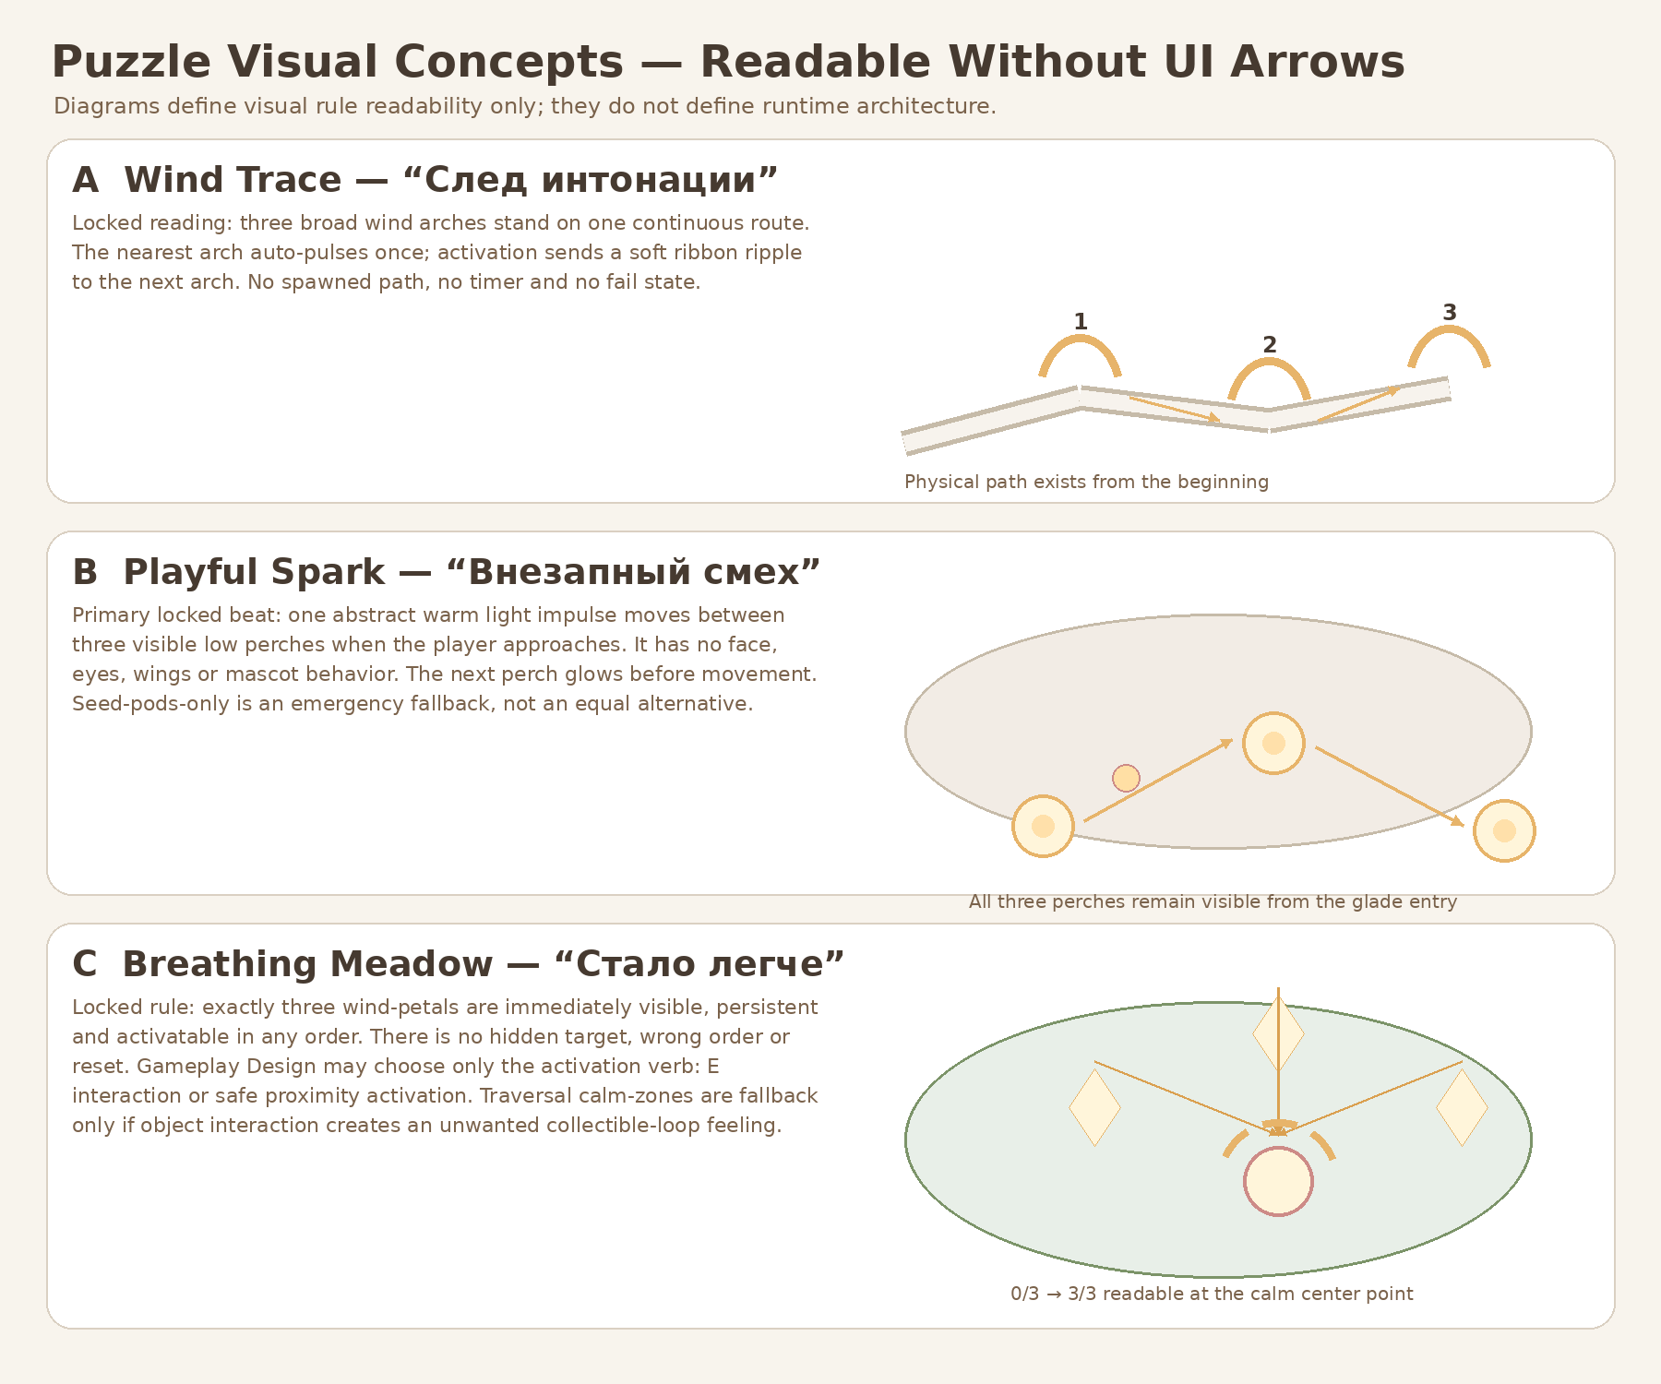
Figure 5. Puzzle readability concepts. Re-exported in v1.1 with clean internal layout and full lower content.

7. Environment state boards
State changes express increasing clarity and inner lightness. They do not imply that the world was dead, that the heroine was broken, or that the player restored her. Natural color and motion are present from the beginning.
State | Locked visual rule | Emotional reading
Initial | Natural stone, green and cloud-blue remain clearly visible. Color richness ≈ 65–80% of final state. World is quieter/cooler, never grayscale, dead or dormant. Mandatory route and landmarks remain readable. | Attentive expectation.
After Shard_05 | Wind ribbons and grass responses become clearer; warm accent appears toward the Playful Glade. | Her intonation remains after the conversation.
After Shard_06 | Golden motes and spark trail expand forward; midground haze softens. | A sudden laugh makes an ordinary moment feel lighter.
After Shard_07 / Synthesis | Motifs converge; Final Overlook Landmark becomes fully readable; Portal Core stays inactive during main text. | Three details become one quiet understanding.
After Main Text / Exit | Portal Core activates calmly and locally after main text closes. No giant beam, explosion or trophy spectacle. | A gentle transition to Level_04.

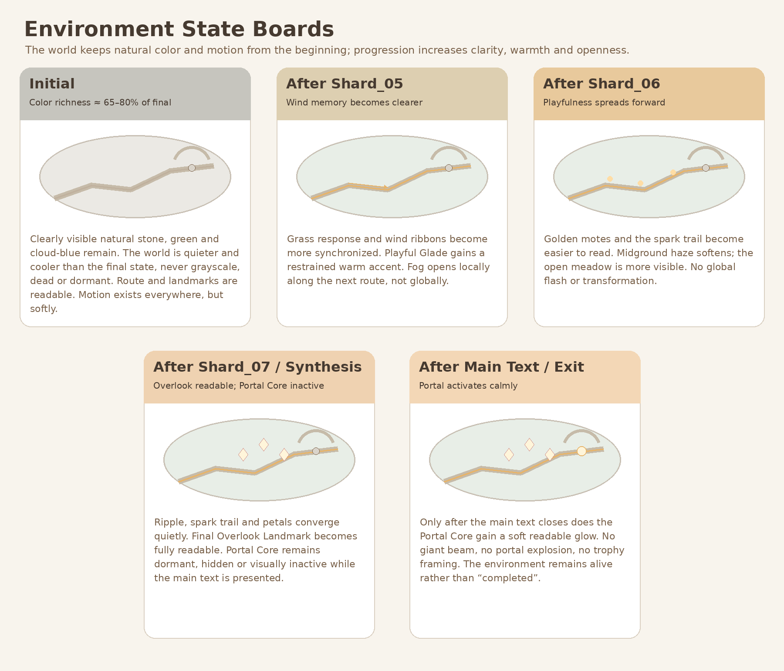
Figure 6. Five environment states, including separate Synthesis and Exit portal activation states.

8. Palette, materials, fog, lighting, natural motion and focal rules
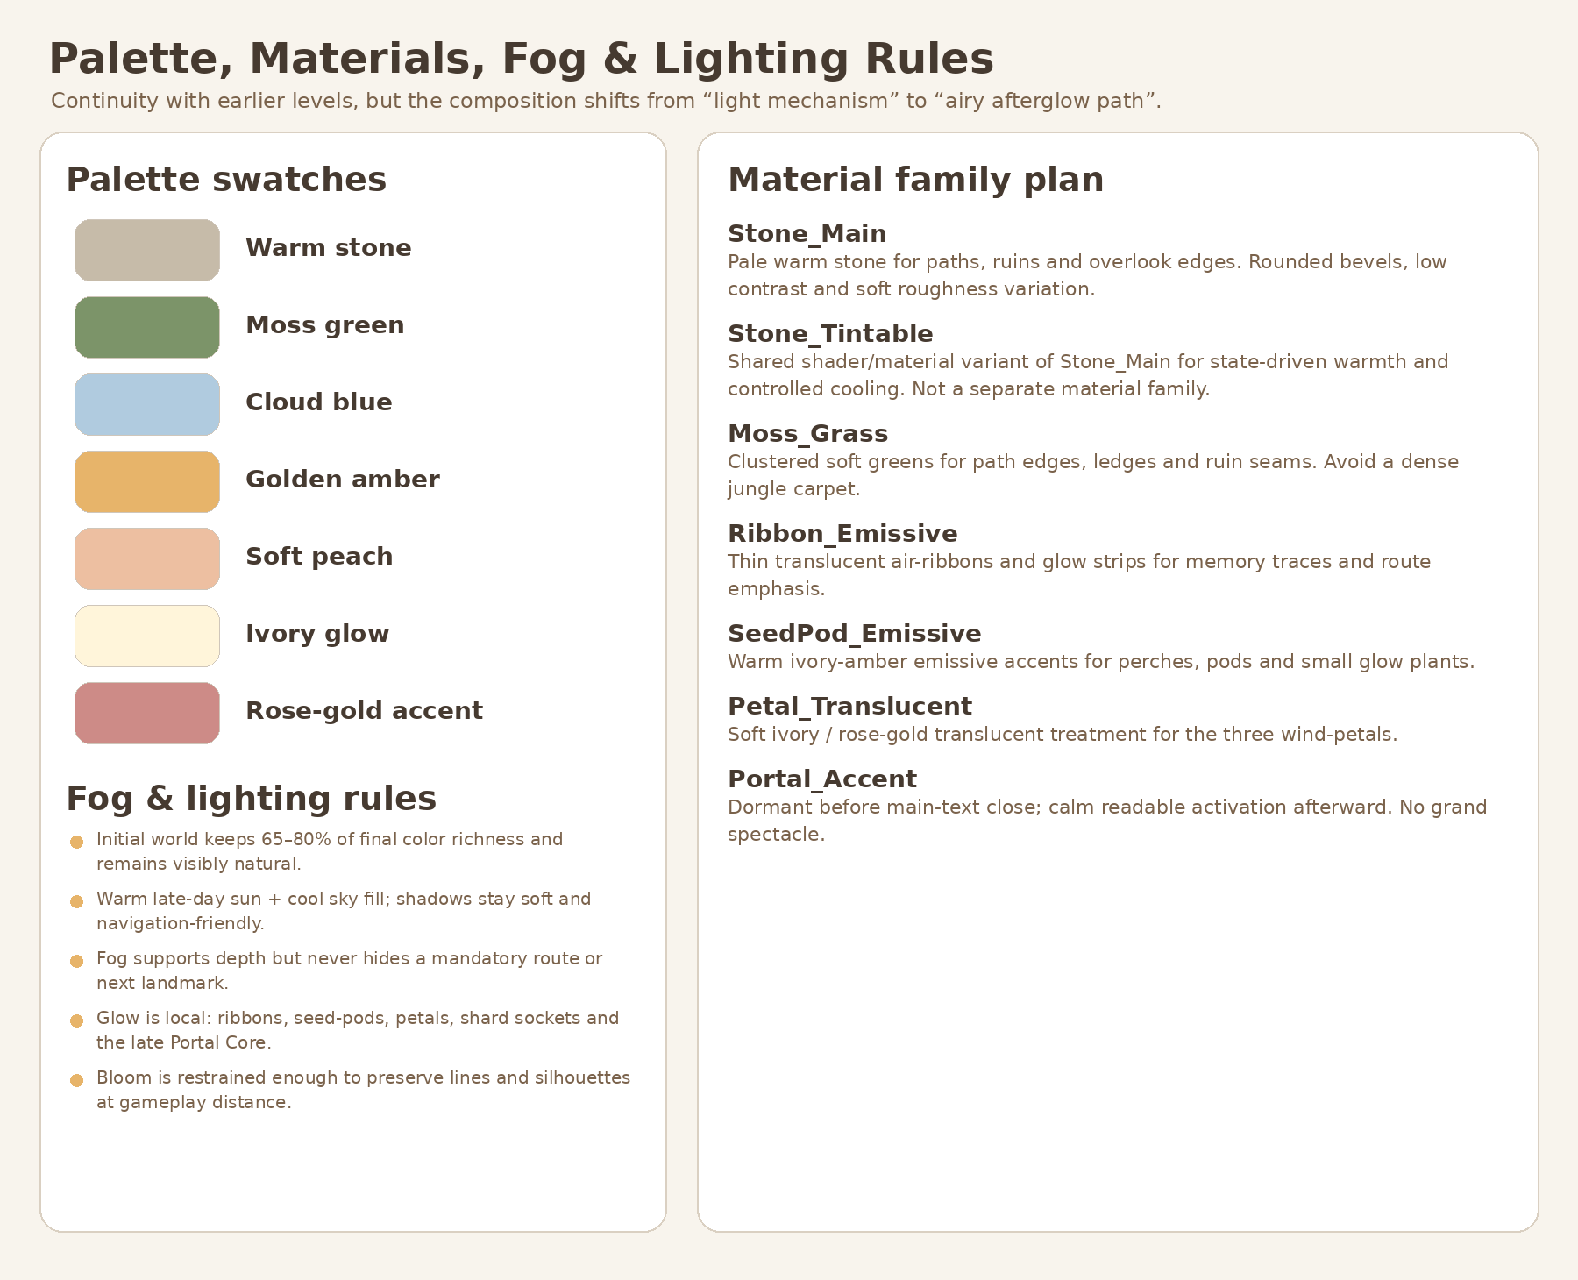
Figure 7. Re-exported v1.1 palette and material plan with clean internal layout.

8.1 Locked palette direction
- Warm stone, moss green, cloud blue, golden amber, soft peach, ivory glow and restrained rose-gold accents.
- Initial state keeps 65–80% of final color richness; it is quieter and cooler, not desaturated into gray.

8.2 Material direction
- Stone_Main is the primary pale warm stone family.
- Stone_Tintable is a controlled shader/material variant of Stone_Main, not a separate full material family.
- Moss_Grass remains clustered and soft; no dense jungle carpet.
- Ribbon_Emissive, SeedPod_Emissive and Petal_Translucent remain local accent families.
- Portal_Accent remains dormant until after main-text close and never becomes a grand spectacle.

8.3 Fog / light / motion
- Warm late-day key light plus cool sky fill; shadows stay soft and route-readable.
- Fog builds depth but never hides mandatory traversal or the next landmark.
- Natural motion exists at all times: ribbons, grass groups, hanging vines, leaves and slow motes.
- Glow remains local and bounded; bloom cannot destroy silhouette readability.

9. Hero asset budget and modular kit proposal
Unique semi-hero family limit is locked at three. A unique Final Overlook composition is allowed, but it must be assembled from shared kits rather than treated as a new full hero family.
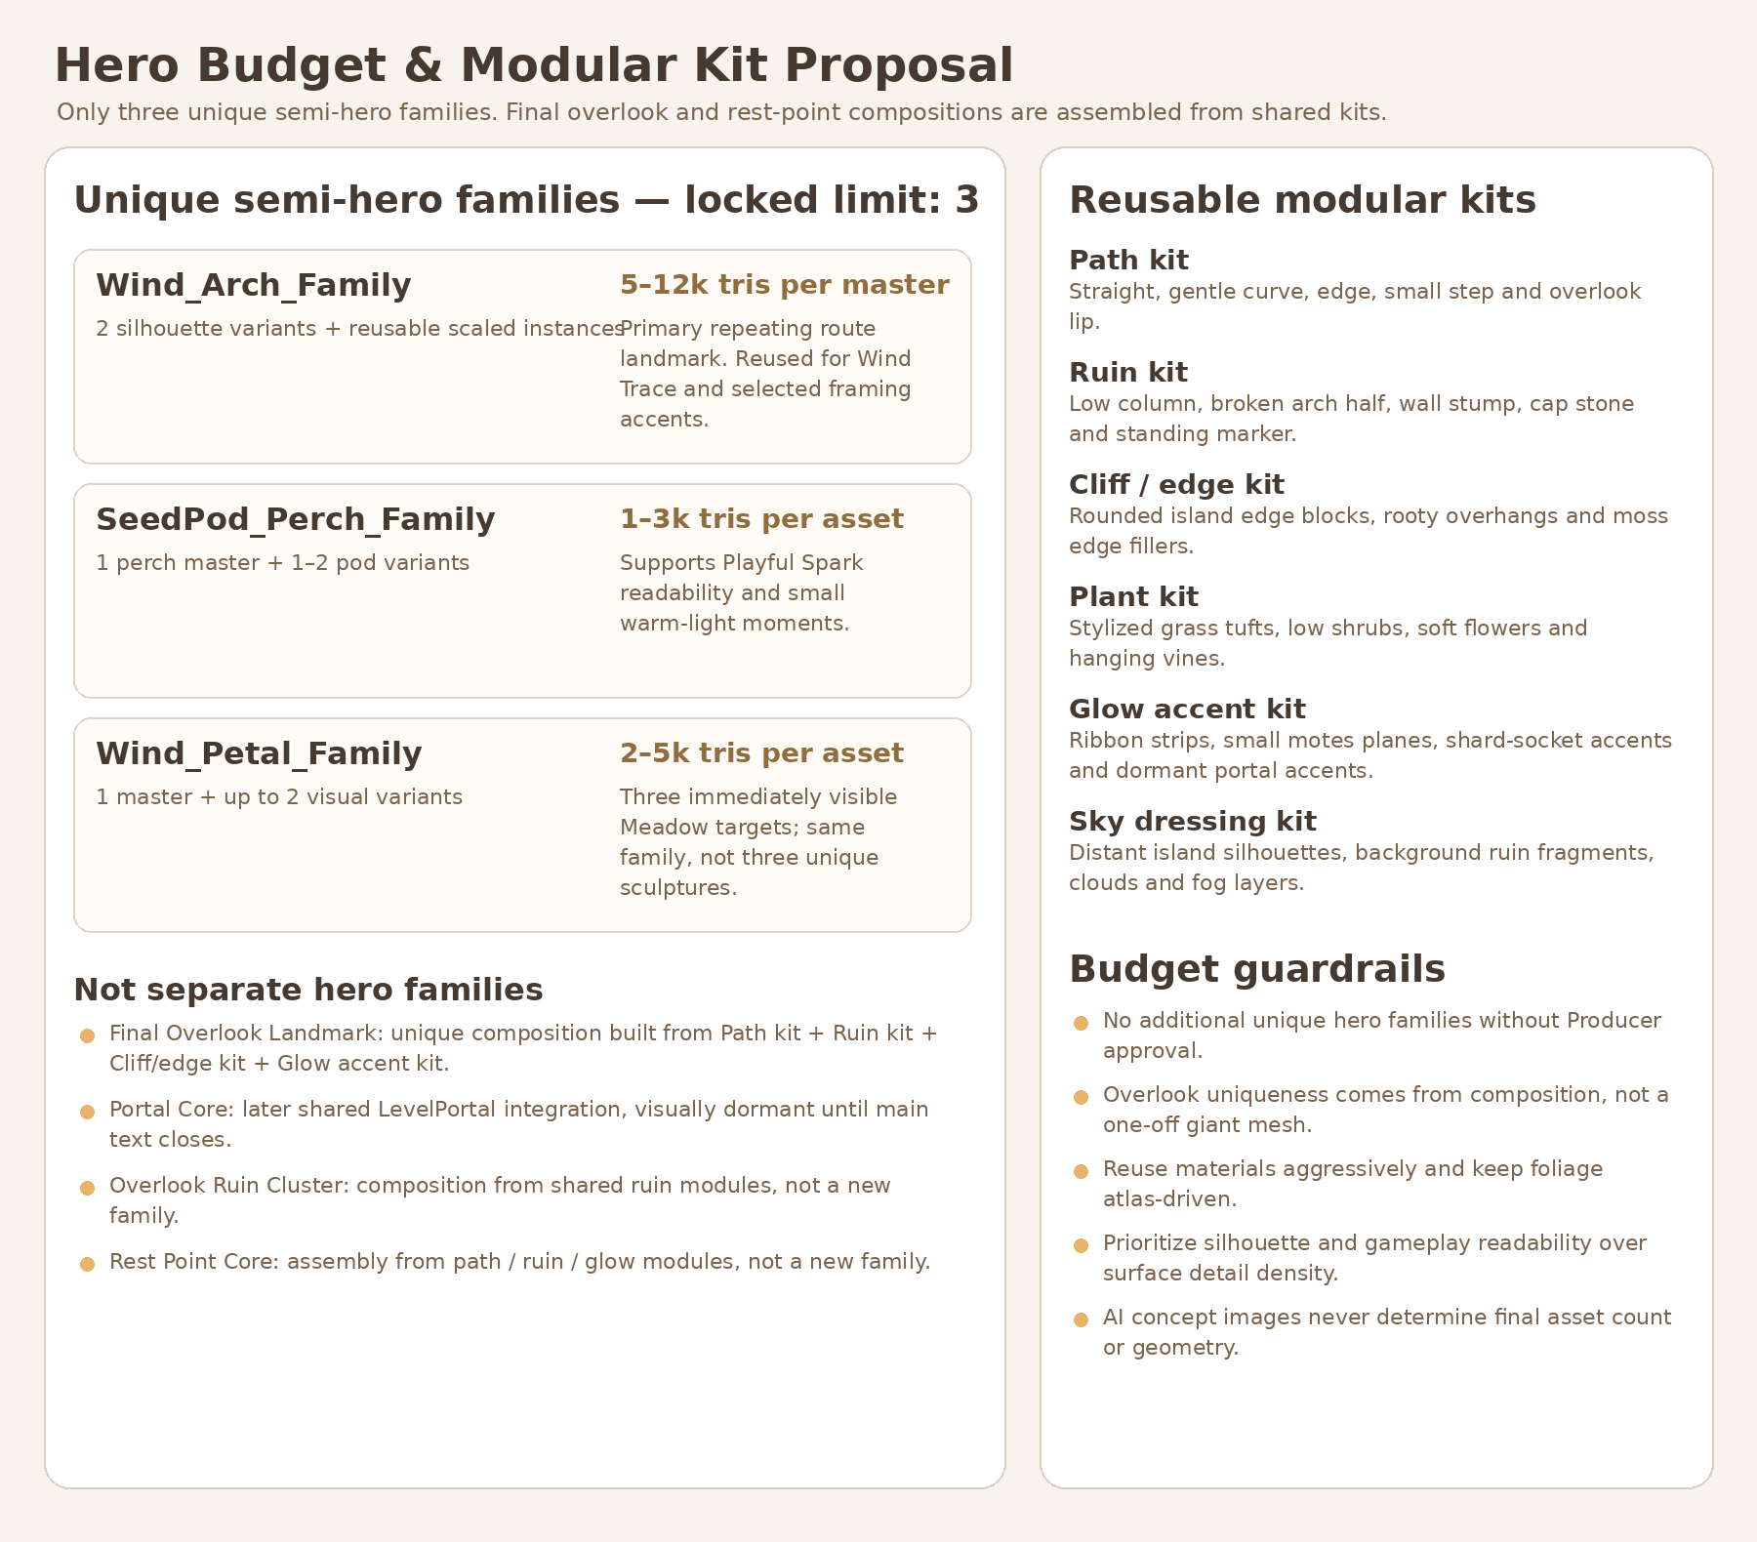
Figure 8. Re-exported v1.1 hero budget and modular kit proposal without overlapping labels.
Category | Locked proposal
Unique semi-hero families | Wind_Arch_Family; SeedPod_Perch_Family; Wind_Petal_Family — exactly three.
Final Overlook Landmark | Unique composition from Path kit + Ruin kit + Cliff/edge kit + Glow accent kit. Not a separate asset family.
Portal Core | Later shared LevelPortal integration. Dormant before main-text close. Not a new Level_03 hero family.
Overlook Ruin Cluster | Composition from reusable ruin modules, not a unique family.
Rest Point Core | Assembly from path / ruin / glow modules, not a unique family.
Reusable kits | Path kit; Ruin kit; Cliff / edge kit; Plant kit; Glow accent kit; Sky dressing kit.

10. Forbidden visual directions
- No dead/grayscale world that becomes alive because of her.
- No circular hub, boss bowl, central arena or three-pedestal challenge composition.
- No altar, shrine, cathedral, sacred-woman framing or giant portal destination visible as active from the beginning.
- No literal voice machinery, speakers, mouth symbols, audio puzzle or dependency on sound recognition.
- No face, eyes, wings or mascot behavior for Playful Spark.
- No hidden wind-petals, wrong order, resets, timers, combat or precision platforming.
- No cyan sci-fi neon, hard white clipping, laser beams or aggressive bloom.
- No extra unique hero families beyond the locked three without Producer approval.

11. Producer approval / lock table before Gameplay Design
v1.1 restores all Producer-locked decisions. Only the Breathing Meadow activation verb remains intentionally open for Gameplay Design.
Decision | v1.1 status | Locked result / remaining scope
Working title | LOCKED | «После наших разговоров».
Narrative copy | LOCKED | Shard_05, Shard_06, Shard_07 and main text from the narrative authority.
Macro topology | LOCKED | Continuous asymmetrical S-shaped sky-grove walk. No central hub or arena.
Puzzle sequence | LOCKED | Wind Trace → Playful Spark → Breathing Meadow.
Playful Spark form | LOCKED | Abstract warm light impulse; no face, eyes, wings or mascot behavior. Seed-pods-only = emergency fallback.
Breathing Meadow targets | LOCKED | Exactly three; immediately visible; persistent; any order; no hidden target or wrong order.
Breathing Meadow activation verb | OPEN FOR GAMEPLAY DESIGN | Choose E interaction or safe proximity activation after greybox readability testing.
Traversal calm-zones | FALLBACK ONLY | Use only if Gameplay Design proves that object interaction creates an unwanted collectible-loop feeling.
Final Overlook Landmark | LOCKED | Visible from the beginning as route-orientation landmark; not an active portal.
Portal Core timing | LOCKED | Dormant before and during main text; calm activation only after main text closes.
Initial color state | LOCKED | Natural color visible; approximately 65–80% of final richness; never grayscale/dead/dormant.
Semi-hero budget | LOCKED | Exactly three unique semi-hero families; overlook/rest-point assembled from shared kits.
Exact runtime coordinates / architecture | DEFERRED | Belongs to later Gameplay Design and Technical Architecture, not this visual concept package.

12. Final visual-development verdict
RECOMMENDED FOR PRODUCER APPROVAL AFTER v1.1 REVIEW. The package now preserves the strong continuous sky-grove direction while removing shrine/arena/giant-portal contradictions. Final Overlook Landmark and Portal Core are separated, the initial state remains visibly alive and naturally colored, Playful Spark and Breathing Meadow decisions are restored as locked, and the hero budget is constrained to three reusable semi-hero families. The document remains visual-development authority only: no runtime architecture, exact coordinates, Blender production, GLB assets, branches or PRs were created.

Appendix A. Handoff boundary
Can pass to Gameplay Design | Must remain deferred
Continuous route topology, relative proportions, sightline rules, puzzle visual readability, 5-state environment language, locked hero-family limit. | Exact coordinates, collision values, NodePaths, state machines, controller ownership, wrapper scenes, GLB hierarchy, final material/shader implementation.

END OF DOCUMENT • VERSION 1.1 • DOCUMENTATION ONLY

